WORKING WITH AMAZON GLACIER

STEPS:

1.Sign into the AWS Management Console and open the Amazon Glacier console at https://console.aws.amazon.com/glacier/.

2.Select a region from the region selector.

In this getting started assignment, we use the MUMBAI region.

3.If we are using Amazon Glacier for the first time, click Get started. (Otherwise click Create Vault.)

4.Enter TEST as the vault name in the Vault Name field and then click Next Step.

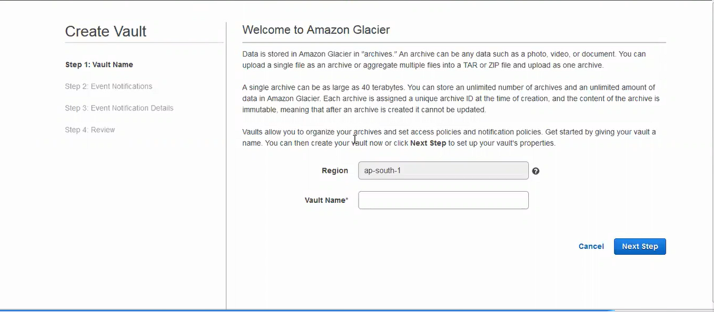

5.Select Do not enable notifications. For this getting started exercise, we will not configure notifications for the vault.

If we wanted to have notifications sent to we or our application whenever certain Amazon Glacier jobs complete, we would select Enable notifications and create a new SNS topic or Enable notifications and use an existing SNS topic to set up Amazon Simple Notification Service (Amazon SNS) notifications.

6.If the region and vault name are correct, then click submit

7. our new vault is listed on the Amazon Glacier Vaults page

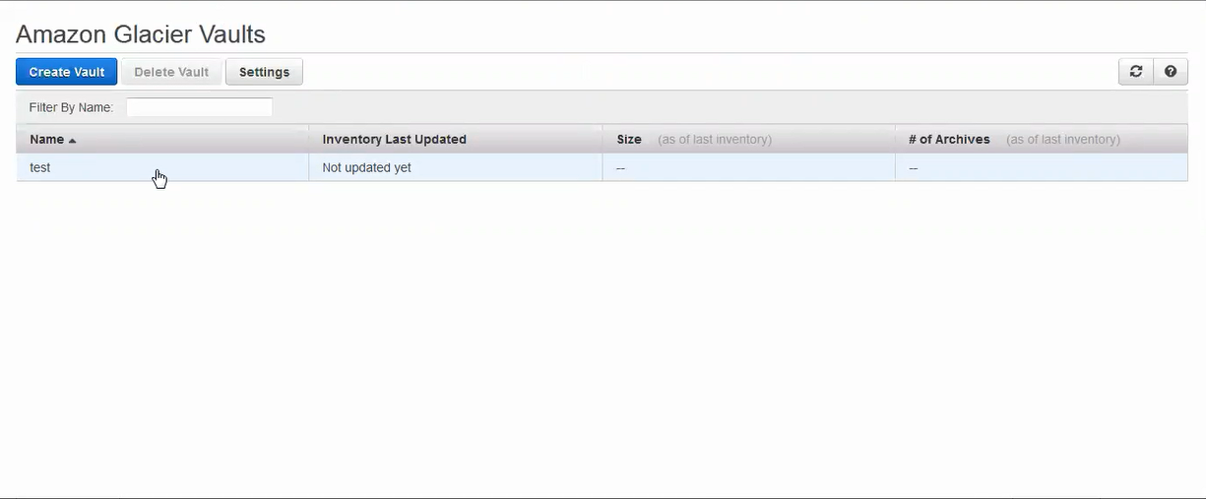

8.click on notifications >permissions>edit policy document

The desired bucket policy will be applied here.

permissions>vault lock policy

It indicates whether the data is critical or non-critical

9.Click on S3>all buckets>create bucket>khadoos >right click on khadoos >properties>click in life cycle>life cycle rules

10.click on whole bucket khadoos >next

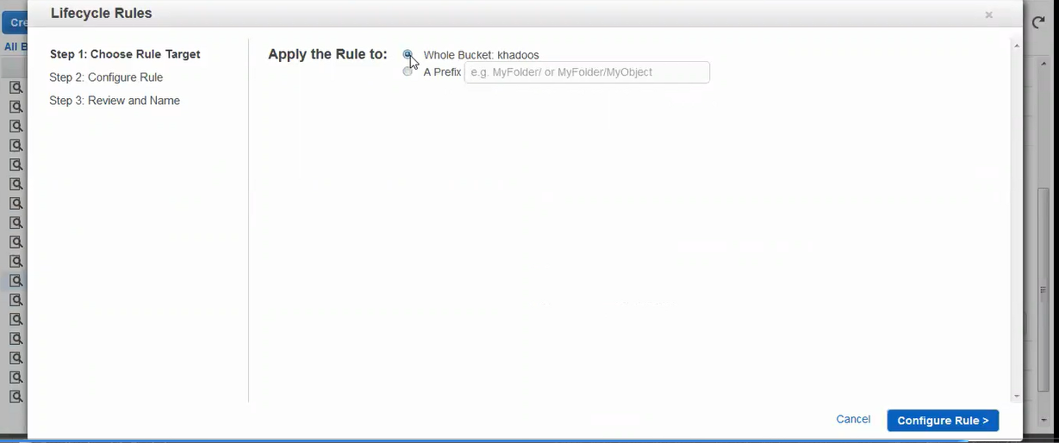

11.click on set target >review>upload.

12.Action on incomplete upload:The rule will end and clean up multi-part uploads that are not completed within a predefined number of days after initiation.

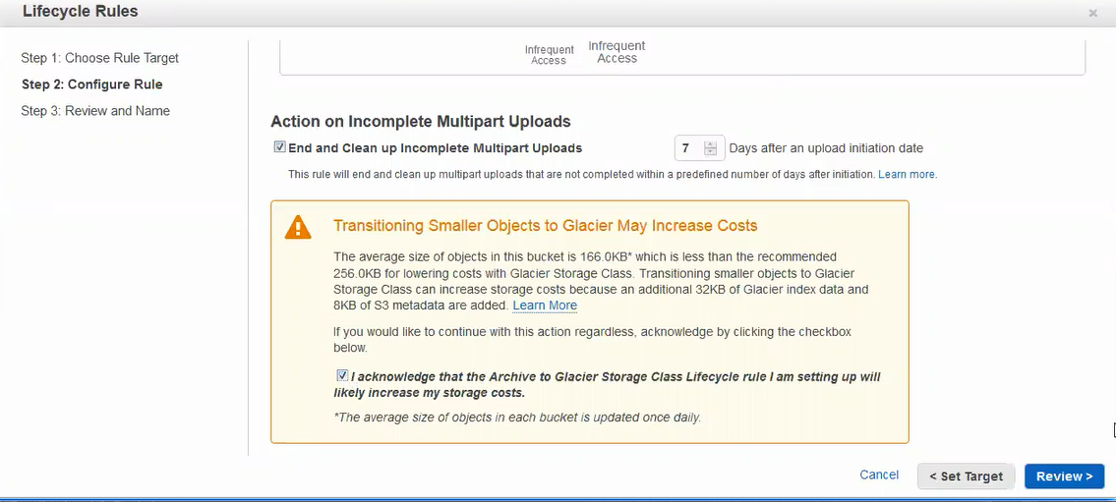

13.click on review >create and activate rule.

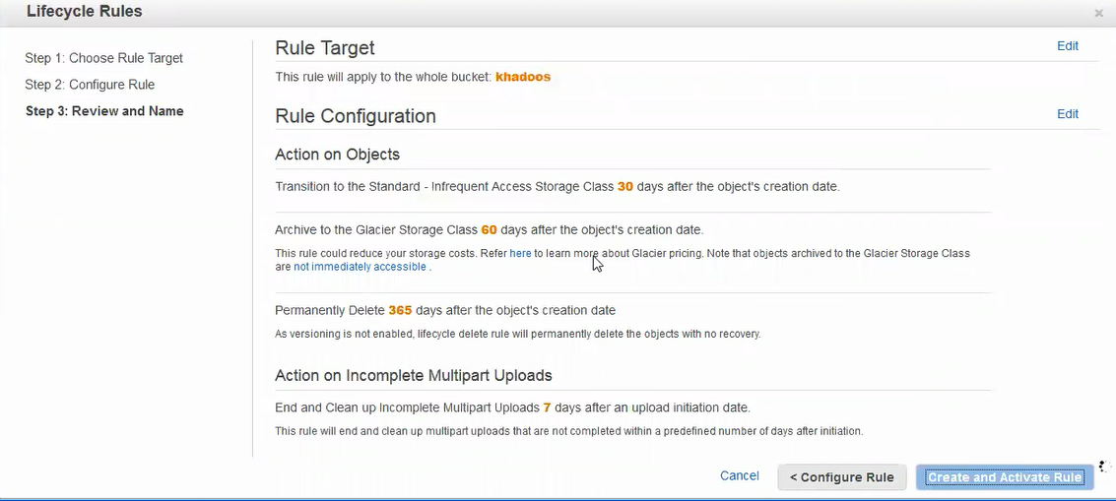

14.click on save.

15.tick on rule for the entire bucket.

All data is now transferred to the glacier